Confirmation Preparation
Sacred Heart Parish

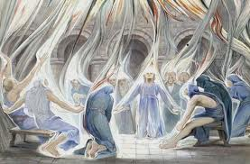
COME HOLY SPIRIT….

Coordinator of Confirmation Preparation
Scott Frieler
sfrieler@sacredheartsaukrapids.org
320-251-8115 ext. 117
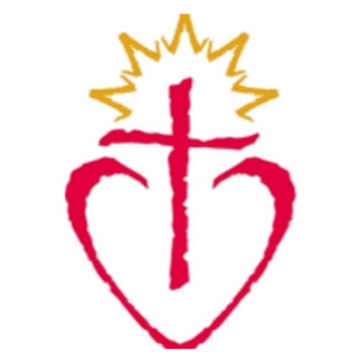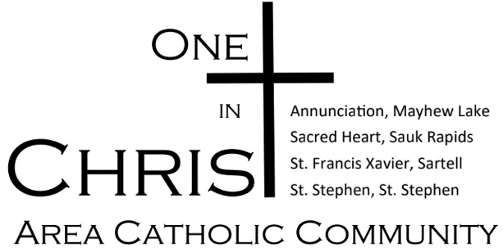
CONFIRMATION PROGRAM 2024

************************************************
Program Goals:

To empower young people to live as disciples of Jesus Christ in our world today.

To draw people to responsible participation in the life, mission, and work of the Catholic Faith community.

To foster the total personal and spiritual growth of each young person.
************************************************

The Diocese requires that we collect a Baptismal Certificate from each Confirmation Candidate for parish record keeping. Students who were not Baptized at Sacred Heart need to provide the parish with a copy of their Baptismal Certificate. If you do not have a copy at home, you can call the parish where your Candidate was Baptized and ask them to scan, fax or mail a copy to Sacred Heart. (Info on last page) Please do this as soon as possible.

Confirmation 2024

Discipleship Training Sessions (DTS)
Confirmation Preparation will be offered to any student in grades 10th grade or older (with students in upper grades getting priority).

- DTS Sessions – 12 Sessions from January – September at Sacred Heart
- Sessions are on Sunday from 7:00 – 8:30 PM

DTS are not academic classes, but Discipleship training which includes experiential learning events, small group discussion, and exercises developed to help the student reflect on their own goals regarding their faith, deepen their prayer life and develop their own unique spirituality.

Expectation of the Candidate Preparing for Confirmation
- Our expectation is that the candidate will be appropriately prepared and involved in a religious education program prior to entering our program. If your child has not been enrolled in another program, additional work may need to be completed before they enter the Confirmation program.

- To participate in the fall of 2024 Confirmation Celebration, all classes and individual assignments must be completed and turned in to Scott Frieler Friday, September 20th, 2024.

- If the student is not able to complete the requirements before that date, all work completed can be “banked” and participate in the next parish Confirmation Ceremony when work is completed.

- By offering the Candidate the ability to work toward Confirmation as they feel compelled to do so, we hope to offer them more flexibility with their schedules and the freedom to choose when they feel ready to receive the Sacrament of Confirmation as opposed to being forced through the system at a specific grade level.

- The Confirmation process is an opportunity for spiritual growth that will require the Candidate’s attention and devotion. We believe that if someone is ready to be Confirmed this attention and devotion will be evident in their actions, and the preparation with be completed well within the deadlines.

Steps in Confirmation Preparation:

Step I: Introductory meeting/Orientation Session.
- Complete the Sacramental Form
- Students Baptized at Sacred Heart can indicate that on the Sacramental Form. If not baptized at Sacred Heart, The parish will need to get a Baptismal Certificate from the parish where the Candidate was baptized as soon as possible. The easiest way to do this is to have the parish fax, scan, or mail a copy to St. Josephs. Information is located on the back page.

Step III. Attend Commitment Sunday Weekend February 3rd & 4th at Sacred Heart Weekend Masses.
All Candidates are expected to be at one of the weekend Masses at Sacred Heart. Mass times are Saturday- 5:00 PM, Sunday 9:00 AM

Step IV. Attend Liturgy Training Event on Wednesday, March 6th at 7:00 PM at Annunciation, Mayhew Lake OR complete 3 Liturgy sheets.

Step V. Complete 7 Approved Service Opportunities- Service is an opportunity to learn about the Gifts given to each of us by God as well as a requirement for Christian Discipleship. Candidates will be asked to complete a minimum of 7 approved service-learning opportunities with 2 of the opportunities occurring at the ACC Service Sundays.
Check the website for a calendar with Service Sunday’s and other Service Opportunities at Sacred Heart under the Confirmation Tab. Once a service opportunity is completed, the candidate will complete a google form. Link will be sent out to candidates in mid-September.

Step VI. Confirmation Mentor Journal: Candidate will meet with their mentor/sponsor regularly to complete the Journal. (The Journal can be found on the website.)

Step VII. 12 Discipleship Training session. Candidate will attend DTS Session from January-September. If you miss a class due to illness, you will be assigned a makeup lesson to be done with your mento/parent. Unless there are special circumstances, any student who misses more than 2 classes during the session, will be required to wait until the next session to start again and be confirmed at the next parish celebration of the Sacrament.

Step VIII. Candidate will Complete Confirmation Learning Centers with a parent. The dates of the Learning Centers are Sunday, February 4th and February 11th from 11:00 – 3:30 PM in St. Stephen. More information to come after January.

Step IX. Retreat experience. All ACC candidates will participate in a Fall and Winter one day retreat experience. The Fall Retreat options are Saturday, September 23rd, Saturday, October 7th and the Diocesan Youth Rally on Sunday, October 29th. Winter Retreat is Saturday, January 6th with additional options on January 13th and February 10th. Candidates may also use the Castaway retreat in March to complete their retreat expectation.
Candidates must attend ACC approved retreat experiences as part of their preparation. Failure to do so, will result in delaying the reception of the Sacrament.

Step X. Candidates will get all documentation required to Scott by Friday, September 20th, 2024.

Step XI. Confirmation candidate will complete a Dialogue with the clergy or ministry staff from our parishes. (Dialogues will be schedule at week or two before the Confirmation Date. This is not a test, but a chance for clergy to meet you and discuss what gifts you bring to the community)

Step XI. Candidate will attend 1 or 2 Additional – Confirmation Preparation Meetings to receive the Sacrament of Reconciliation and Practice for the Ceremony.

Step XII. Attend the Confirmation Ceramony (Date to be Determined)

Where can I find updates with the Confirmation Preparation?

1. Watch your Emails. (Please check your email at least once a week)
- Emails will be the primary way to communicate events and opportunities.

2. Check the Sacred Heart Parish Website
- Go to the Sacraments tab and click on Confirmation.

CONTACT INFORMATION

Confirmation Coordinator: Scott Frieler:
Email Address- sfrieler@sacredheartsaukrapdis.org
Address: 2875 10th Ave NE, Sauk Rapids MN 56379
Phone: 320-2518115 ext. 117
Text: 320-492-8604
Our web page: https://www.sacredheartsaukrapids.org/

ACC Pastors: Fr. Tom Knoblach & Fr. Ron Wyrens

Confirmation Candidate Checklist for your fridge:

- Complete 7Approved Service Opportunities. Parent or Mentor are encouraged to participate as able. (2 Opportunities are with the ACC Sunday Service Days)
* *
* *
* *
*

- 10 Discipleship Training Sessions:
Attend 2 final all-group sessions:

- Attend Liturgy Training Event (Wednesday, March 6th @ 6:30 PM at Annunciation, Mayhew Lake) or complete 3 Liturgy Sheets

- Attend a Fall and Winter Confirmation Retreat
    - Fall Retreat ( Multiple Options)
    - Winter Retreat (Saturday, January 6th)

- Attend Commitment Weekend Mass at Sacred Heart the Weekend of February 4th or 5th

- Complete a Journal with your Mentor.

- Attend the Learning Sessions @ St. Stephen either Sunday Feb 4th or Sunday Feb 11th

- Students will meet for a Confirmation Dialogue in the weeks preceding Confirmation with either the clergy or staff.

All documents can be dropped off at the Sacred Heart Parish Office or Emailed to Scott.
