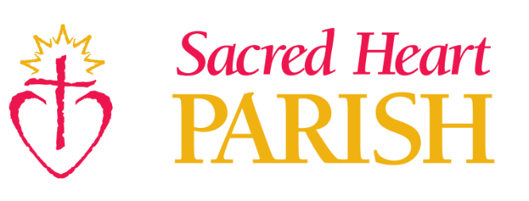
Sacred Heart Faith Formation

September 2023

Dear Sacred Heart Faith Formation Family,
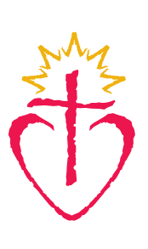
Hello everyone! It is so exciting to begin our new year of K-8 Faith Formation at Sacred Heart. It will be wonderful to have our halls filled with children and families again on Wednesday nights.
- New for 2023 -24 Foundation Family Nights
  - This program year there will be 4 Foundation Family Nights for whole family formation. Foundation Nights will begin with the worship space with families sitting together for Praise and Worship and short reflection. The children will then be dismissed by grade to the Small Group spaces and parents are encouraged to stay for a special presenter each night. The Foundation presentation will end at 7:30 PM and parents will then be able to pick up their children from their small group space. The Schedule for Foundation Nights and presenters are below
    - Wednesday, October 4th – Finding Balance – Self Care with Bethany Tollefson, Diocesan Health Care Ministries
    - Wednesday, December 6th – Advent – Christine Pinto, Associate Director of Faith Formation, Diocese of St Cloud.
    - Wednesday, February 7th - Marriage and Eucharist with Fr. Tom Knoblach
    - Wednesday, April 3rd: To be Determined.
- K-8 Faith Formation will generally meet 2 to 3 times a month from 6:30 – 7:30 PM from October -April. The format follows the natural breaks due to holidays and allows opportunities for a more relaxed preparation and integration of the lessons.
- K -8 Programming will be flanked by children’s choir from 5:30-6:20pm (those participants will receive a calendar of practices from the Liturgy Coordinator) and Grounded Youth Ministry beginning around 7:30pm and ending at around 9:00pm which will be held on the first and third Wednesdays of each month.
- The Sacred heart Café is back again serving from 5:00 -6:20 PM on K-8 faith formation nights.

- Elementary grades 2nd -5th will be using “Discover” Curriculum from St. May’s Press K-1 will be changing to a curriculum called Allelu
- Middle school grades (6-8) will use St. Mary’s Press curriculum, “Connect,” Year Two.
- A letter has gone out to those seeking First Sacraments. If you have any questions, please let me know.
I am so excited to partner with all of you in sharing the Good News of Jesus with your children. Please feel free to contact me at any time with questions, concerns, or suggestions.
Peace of Christ,
Scott Frieler
Director of Faith Formation
Sacred Heart Parish
2875 10th Ave. NE
Sauk Rapids, MN 56379
320-251-8115 ext. 117
sfrieler@sacredheartsaukrapids.org
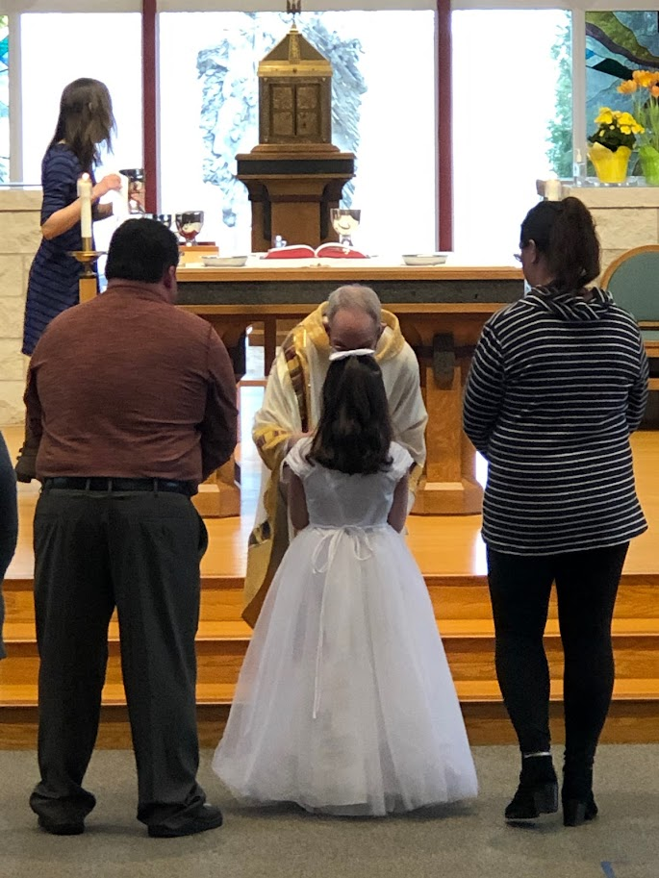
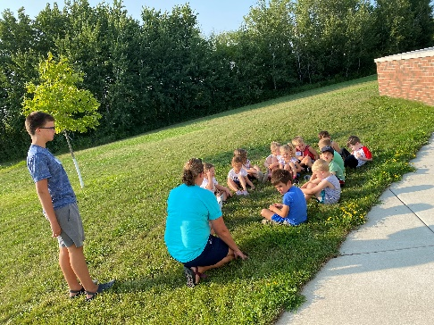
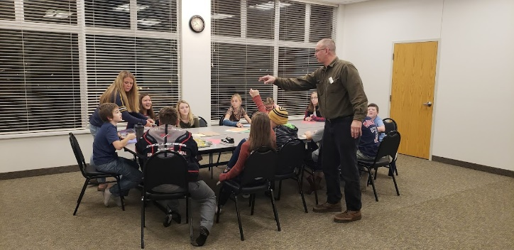

Sacred Heart Faith Formation Mission Statement:
Walking with all generations, Sacred Heart Faith Formation strives to equip parishioners to recognize, claim, know, and live out their faith in the church in the world.
Sacred Heart Faith Formation Goals:
Our parishioners will…
- Become curious about Christ and his ways.
- Grow in their sense of belonging to Christ and the Christian community.
- Gain interest and therefore knowledge in foundational beliefs and elements of the faith.
- Deepen participation in the life of the church through liturgy and worship.
- Practice missionary discipleship through Christian service.

Sacred Heart Faith Formation Handbook

FAITH FORMATION WELLNESS POLICY
At Sacred Heart Church, we strive to provide a healthy environment for all and ask those experiencing symptoms of communicable illnesses refrain from in-person activities. We will do our best to maintain a safe environment and follow all guidelines and protocols set forth by the Diocese of St. Cloud, but with any gathering there is a risk.
Before attending a faith formation session at Sacred Heart
- Please scan your child for Covid or Influenza symptoms. If you have questions about symptoms to look for, please go to the CDC website.
  - https://www.cdc.gov/coronavirus/2019-ncov/symptoms-testing/symptoms.html
- If your child is displaying any symptoms, please do not send them to Faith Formation.
- If you have any questions about the wellness policy, please feel free to contact me at the Faith Formation Office.
- Emergency Contacts- Parents will be notified immediately if their child starts feeling unwell. Please be sure your contact information and your emergency contact information are correct and up to date!

Additional information…
- Grade K – 8 Drop off/Pick Up Procedure–

  - The only outside doors that will be used on Faith Formation Nights is Door 5 by the Parish Office. All other doors will be locked.

  - At the beginning of the Session, parents will take their child(ren) to their meeting space. The parent will sign in the child when the arrive. On Foundation Nights, parents will not have to sign their children in as they will be dismissed from the Church.

  - At the end of the session, a parent will be asked to sign out youth who are 4th grade and under by going to their meeting space. Siblings are not allowed to sign out another sibling.

  - 5th – 8th grade youth may be excused by their Adult Leader from the small group space. They will still exit the building using the Parish office doors.

- Weather Related Cancellations – Weather related cancellations will be posted on the Parish Facebook Page, Parish Website and on the WJON website. Please monitor these sites for information or any further updates or contact Scott in the Parish Office with any questions. (In general, Faith Formation will follow the decisions of the Sauk Rapids/Rice School District.)

- Food Allergies – There are participants with nut allergies in the Faith Formation program. If you child brings a snack, please make sure it is from a nut free facility. Also, please visit with the Adult Leader before bringing food to a session.

- Sacred Heart Child Discipline Procedure

  - The Sacred Heart Faith Formation program creates an environment where all participants and leaders can learn and grow closer to Jesus in a safe environment.

    - The following behaviors will not be tolerated
      - Harassment or bullying in any form.
      - Behaviors that impact the leader’s ability to teach the lesson or impact other children’s ability to participate.
      - Behaviors that are dangerous to the participant of other members of the group.
    - If these behaviors occur, the following is actions will be taken.
      - Child will be removed from the group and sent to the Office with a God Squad member and will meet with the coordinator or appointed individual.
      - Parent will receive an email or phone call regarding child’s behavior.
      - If a child is removed from a classroom 3 times, a meeting will be schedule with the parents to determine if alternative models for faith formation are needed.
      - Violent or dangerous behavior will lead to immediate removal from the small groups and require a meeting the Director Faith Formation.

- Volunteers are essential to the success of the Faith Formation Program, and you can do it. There are always opportunities to help with Faith Formation. If you have any questions, please call or email the Faith Formation Office.

